Application Deployment
(Deploy the given React application to a production ready state)

Application:
Clone the below mentioned repository and deploy the application (Run application in port 3000).
Repo URL : https://github.com/Vennilavanguvi/Trend.git

Docker:
- Dockerize the application by creating Dockerfile
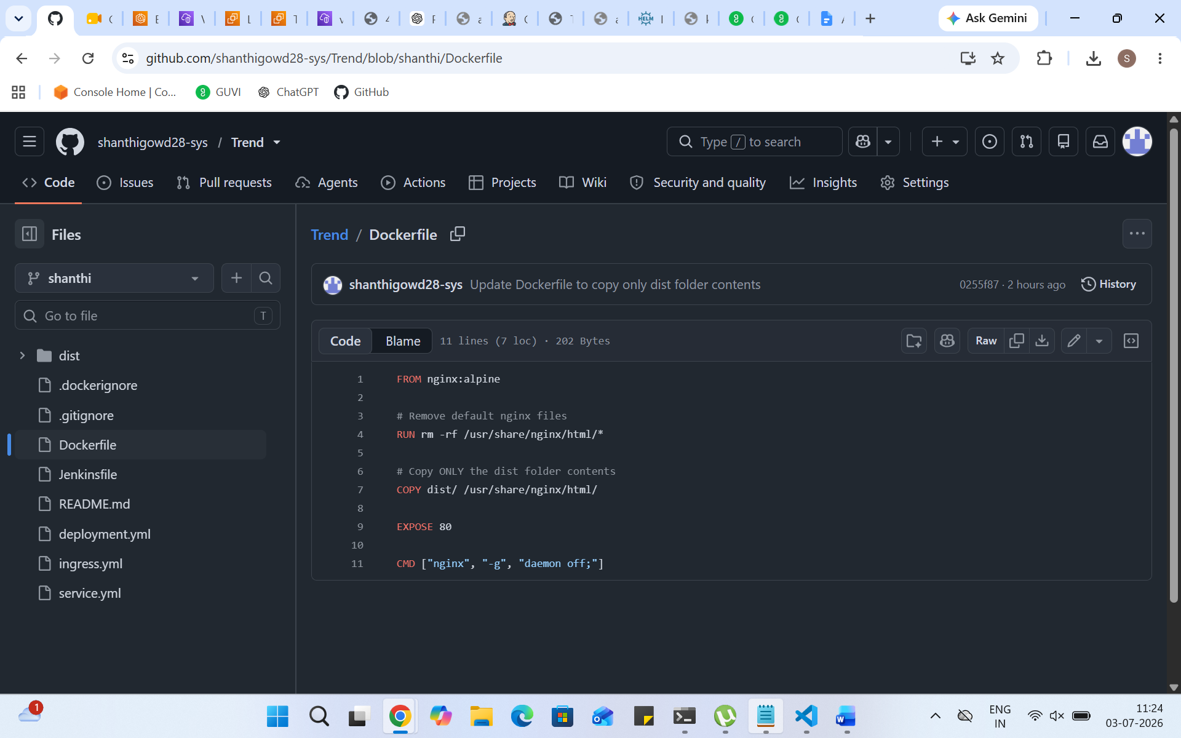
- Build an application and check output using docker image.
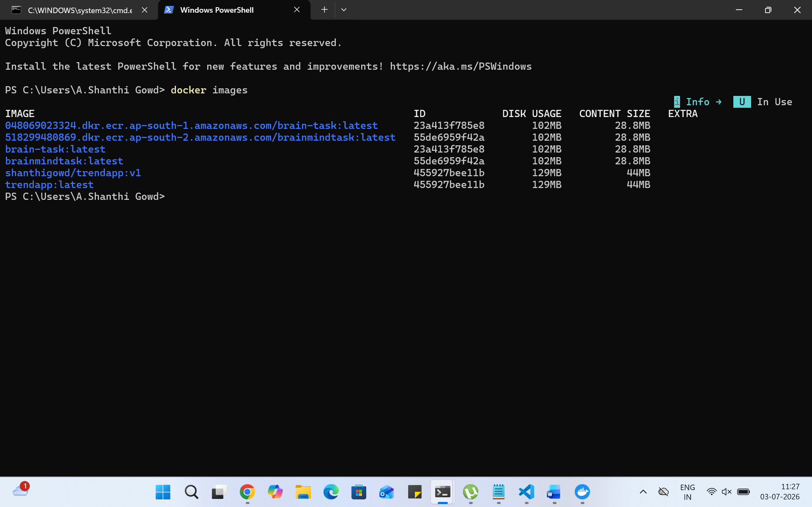

Terraform:
- Define infrastructure in main.tf to create VPC, IAM, EC2 with Jenkins, etc.
- 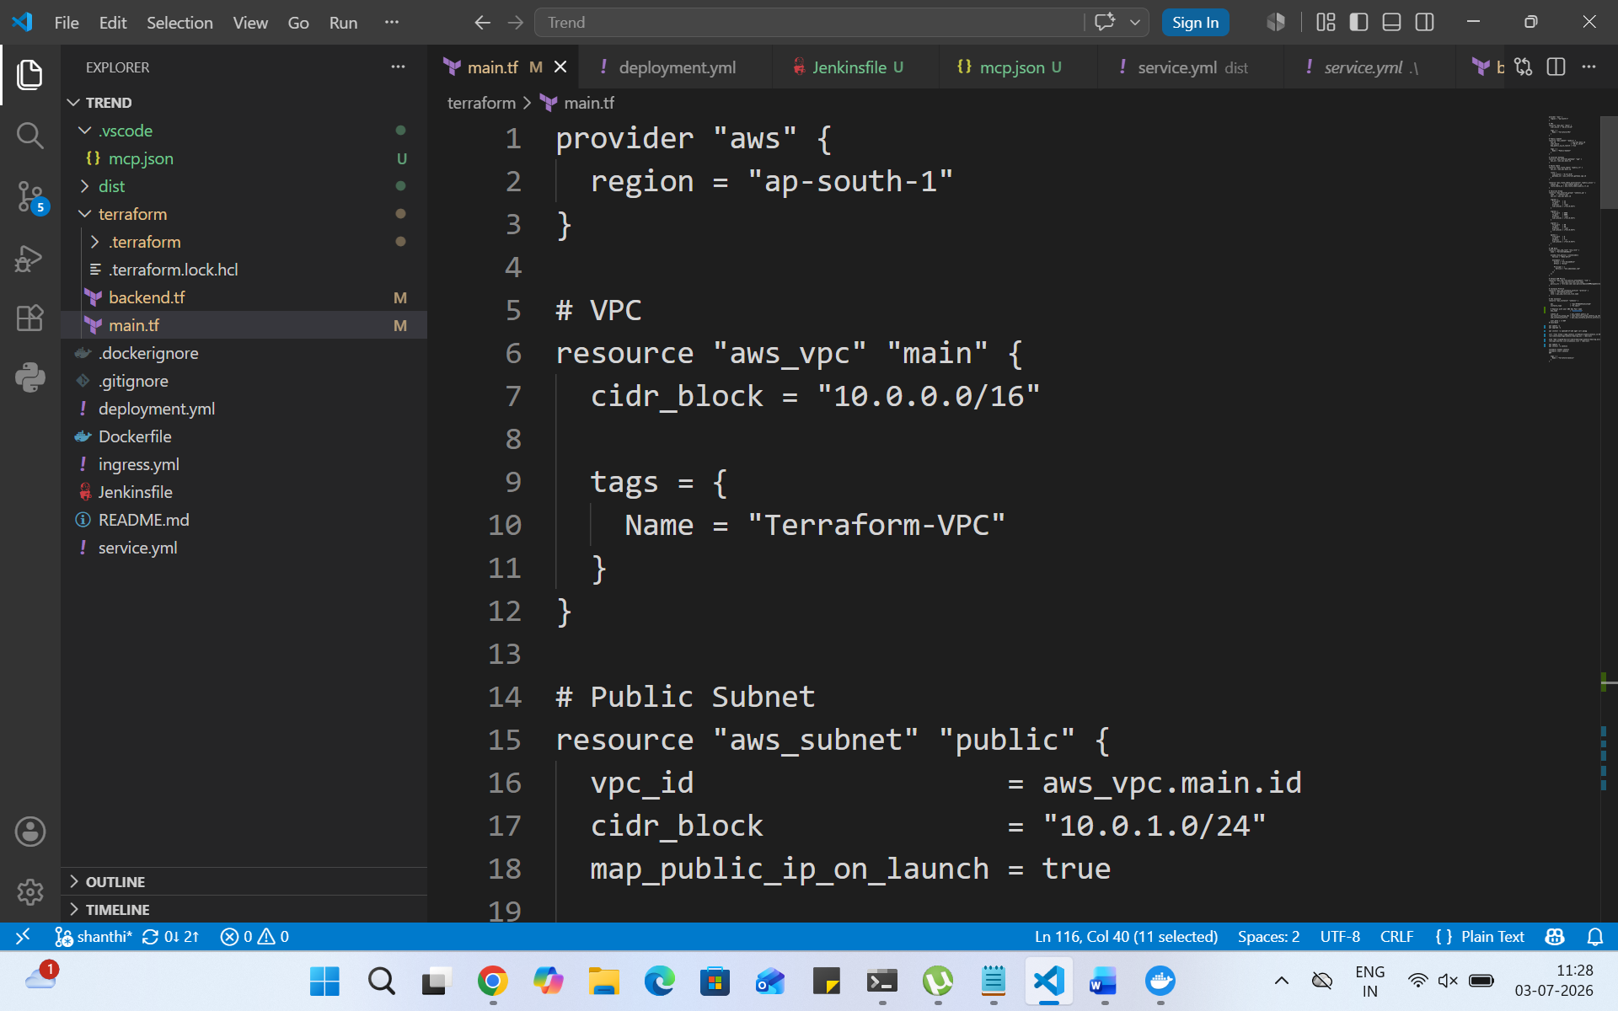
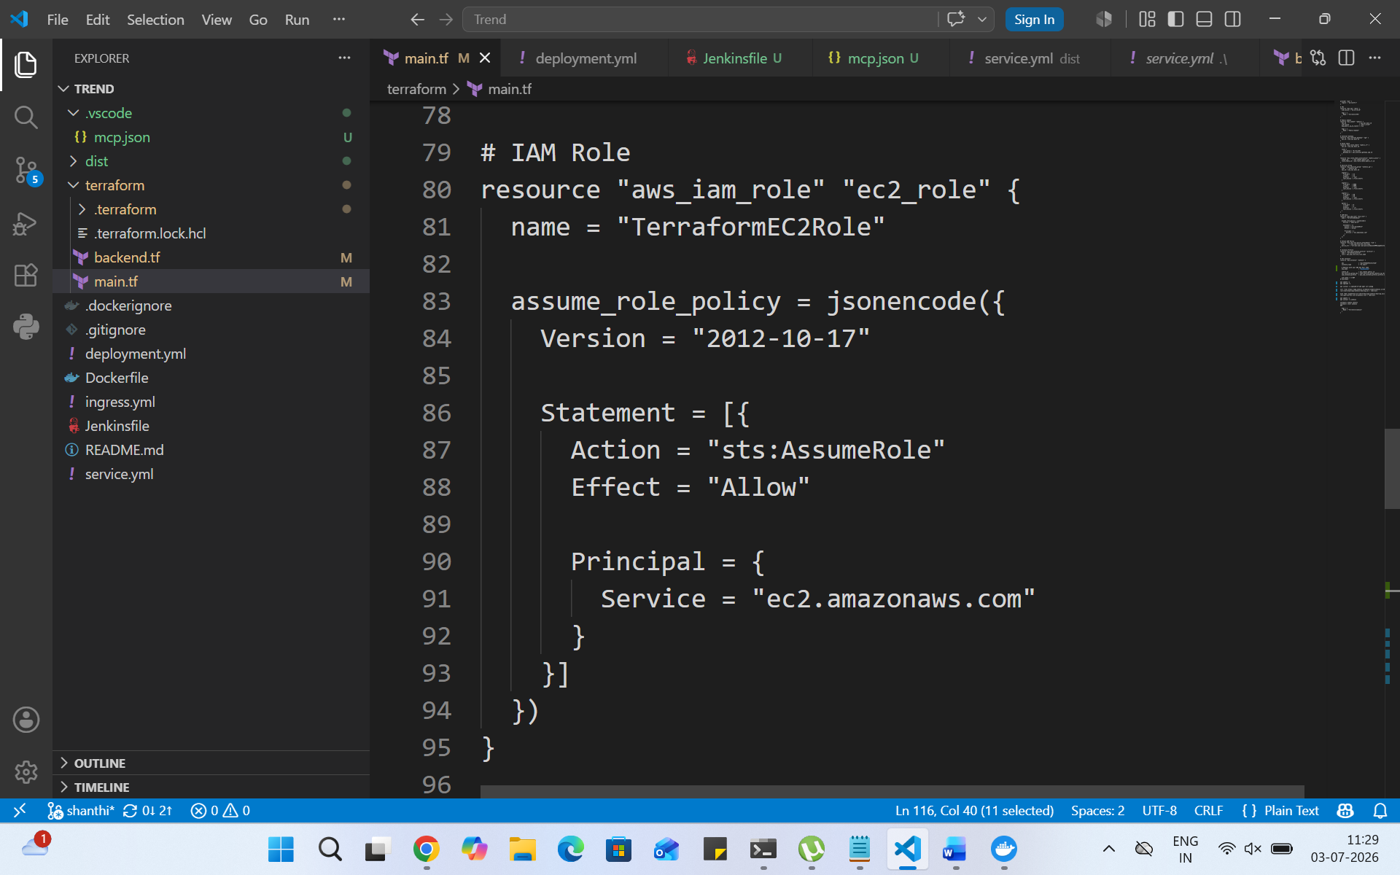
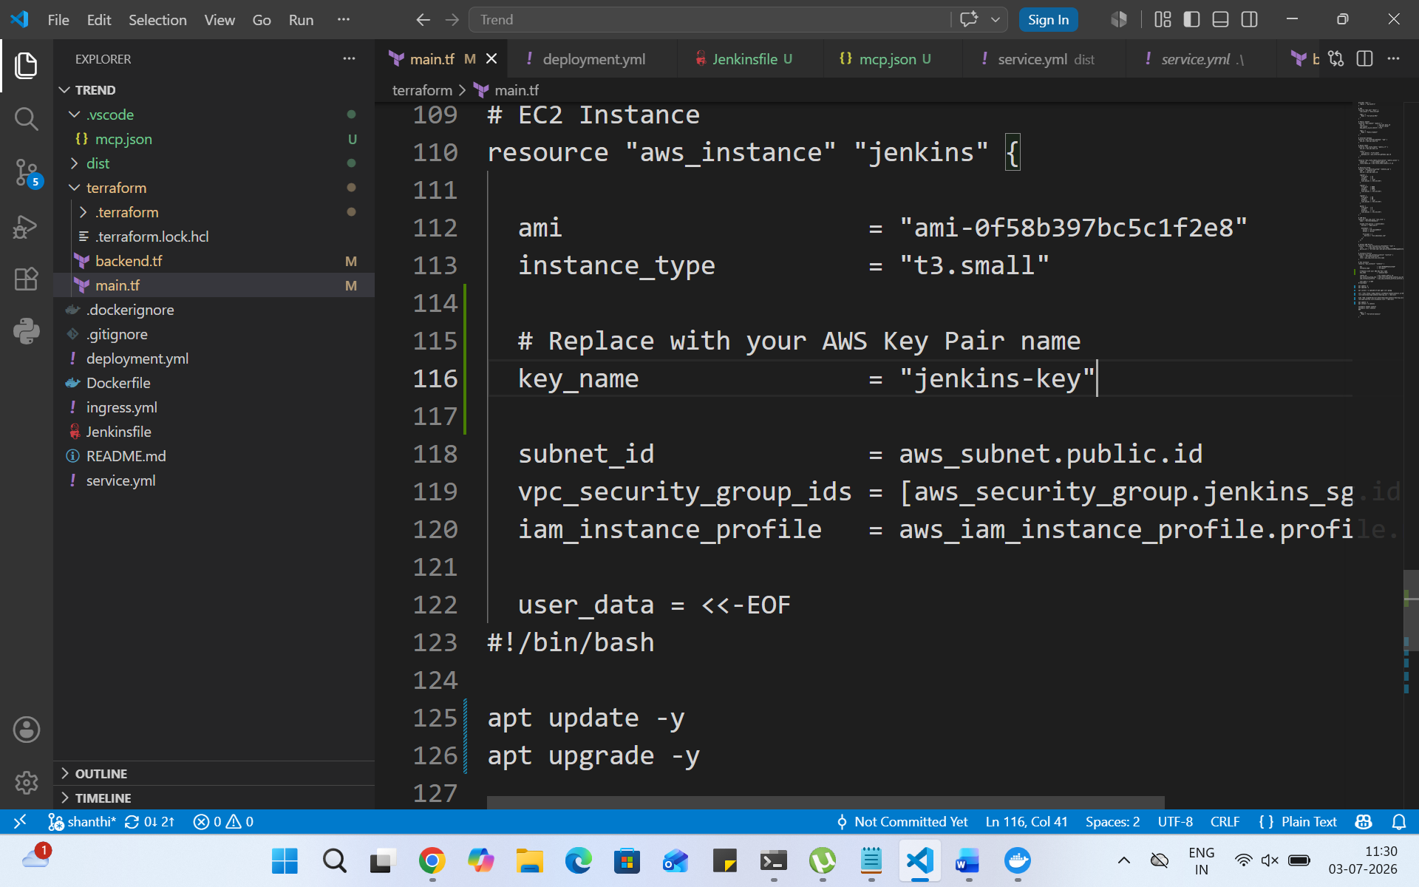
- Use terraform command to provision infrastructure.
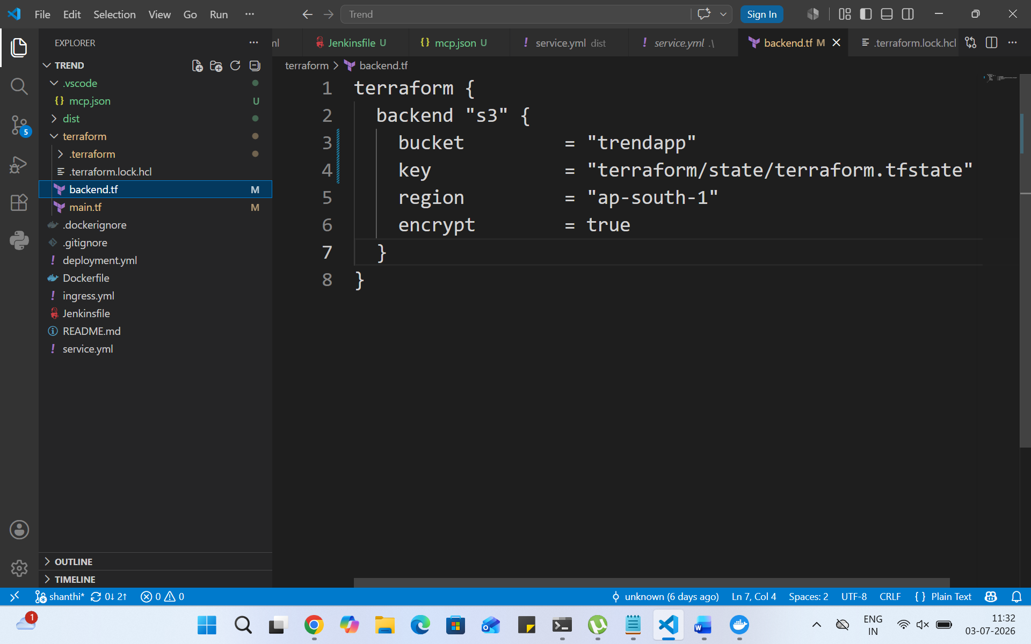
DockerHub:
- Create a DockerHub repository.
- 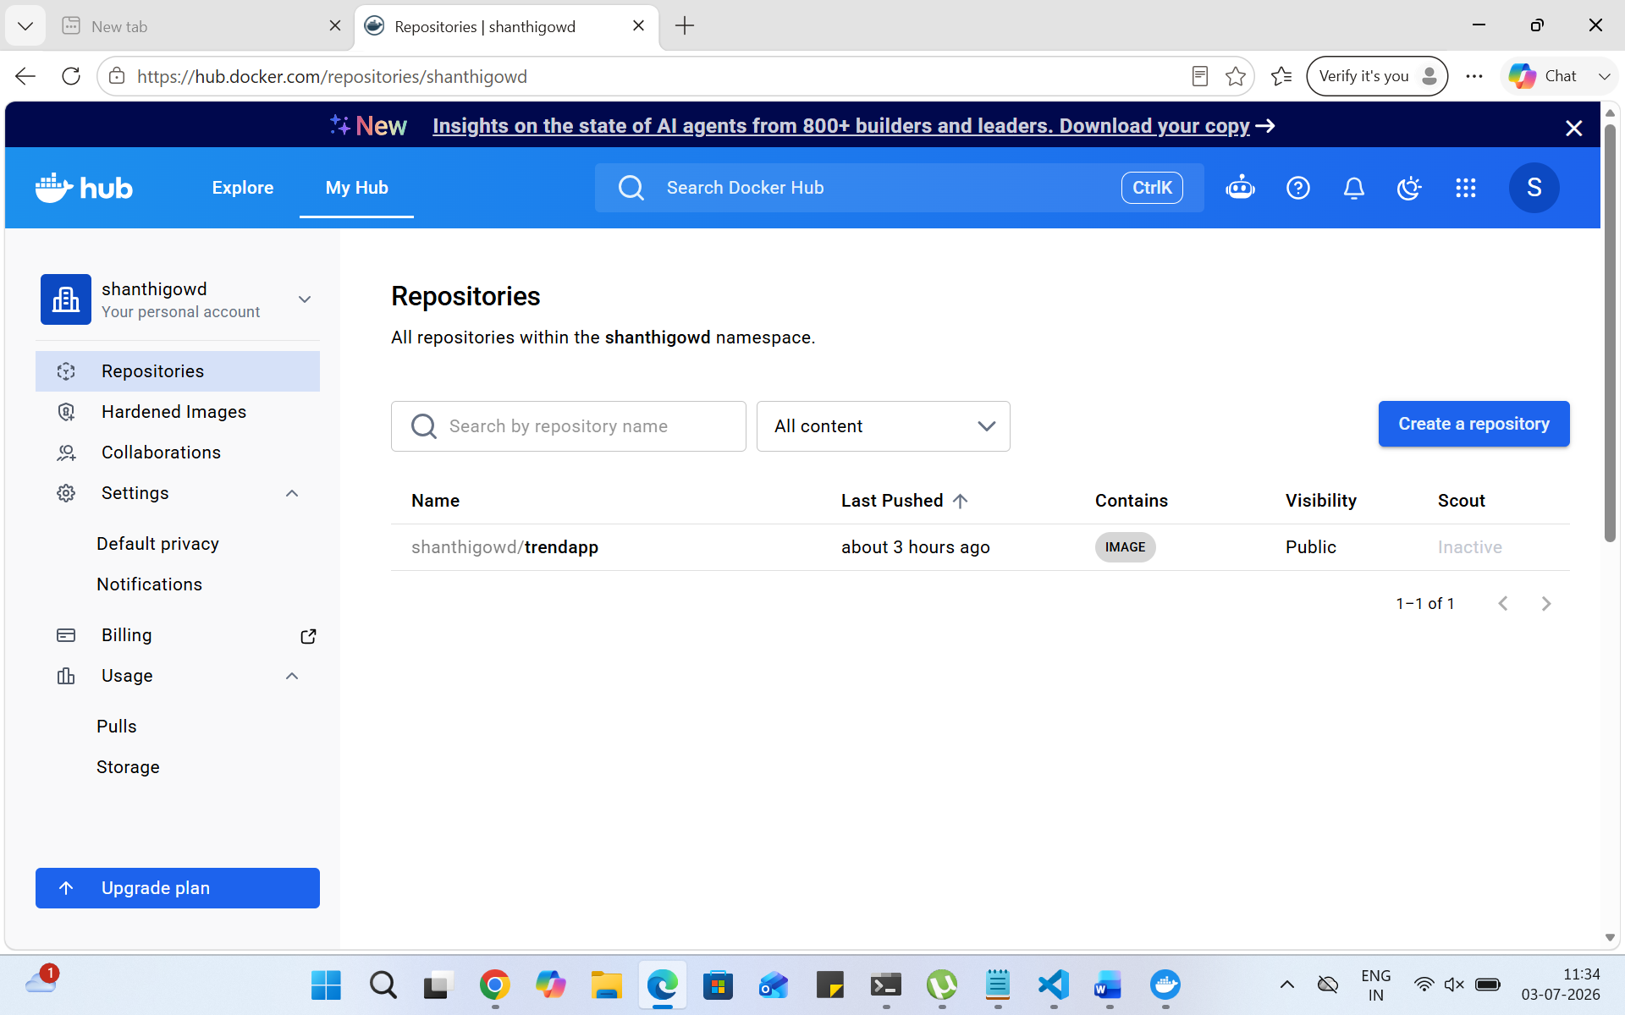
Kubernetes:
- Setup Kubernetes in AWS EKS and Confirm EKS cluster is running.
- 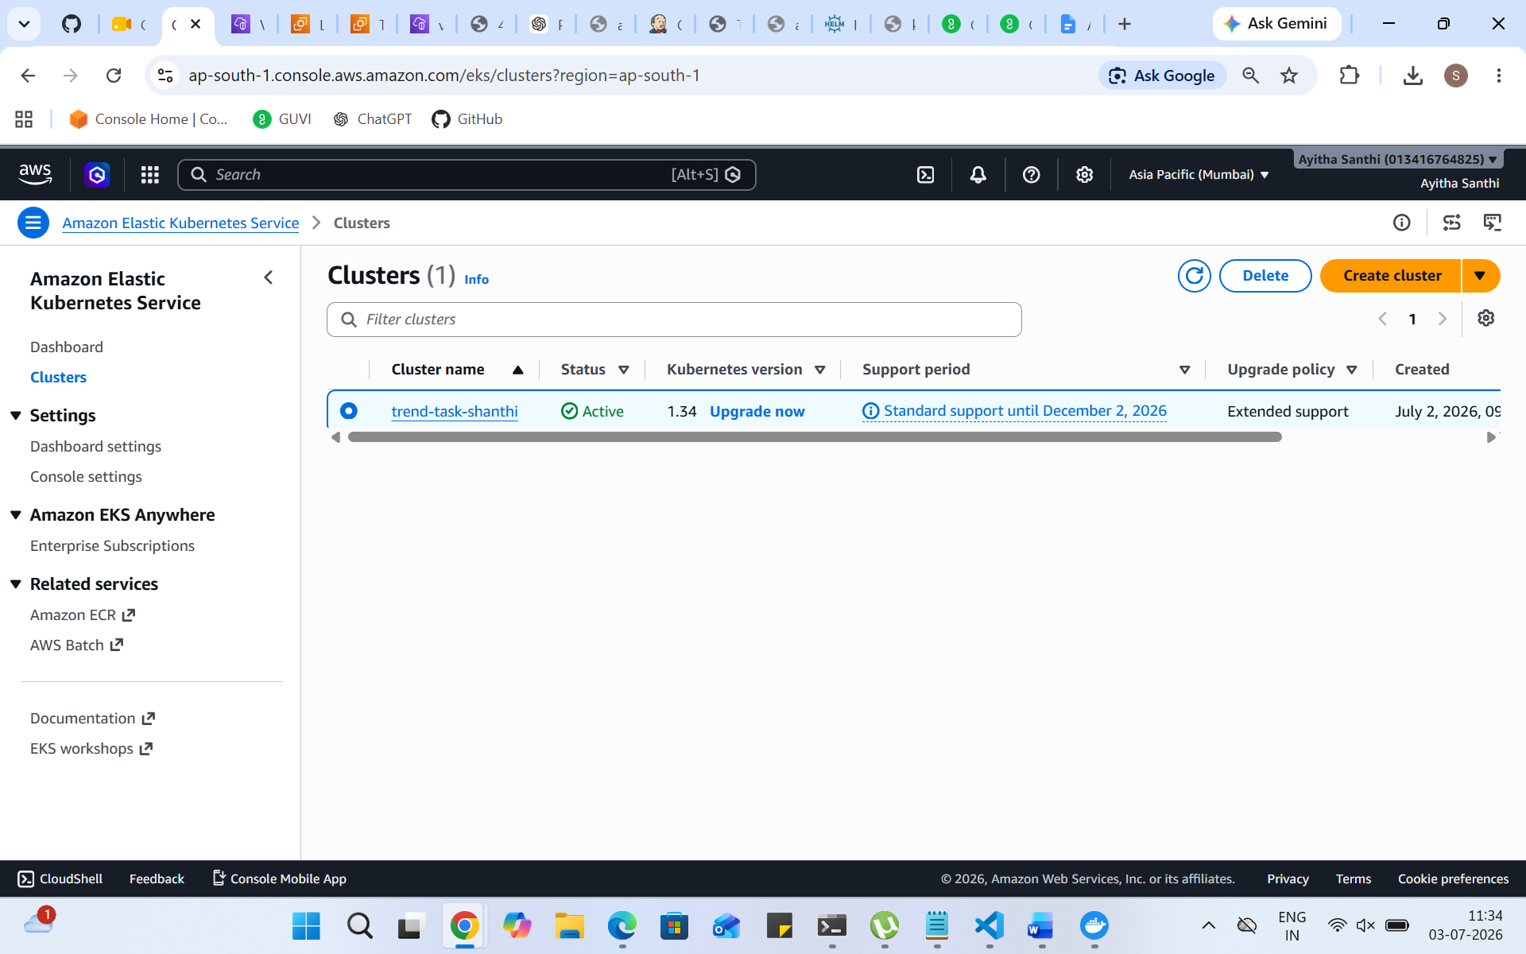
- Write deployment and service YAML files.
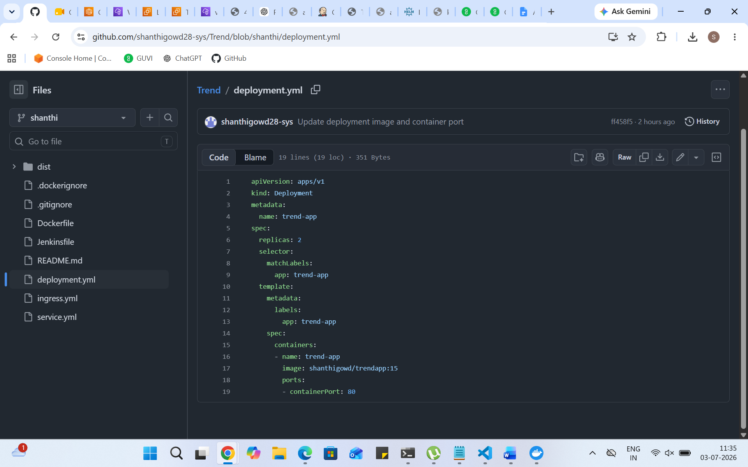
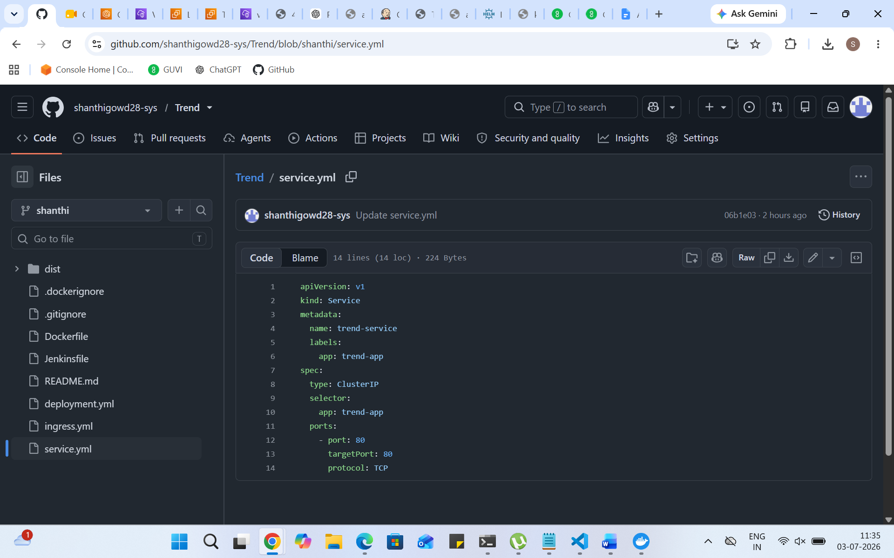
- Deploy using kubectl via Jenkins.

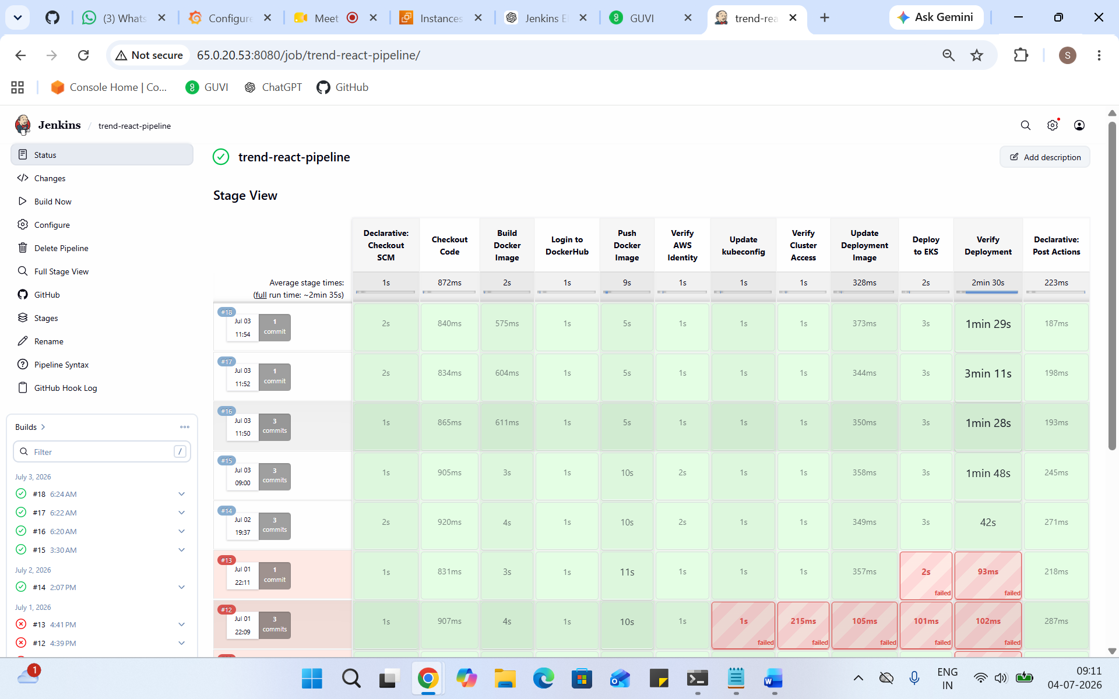
Version Control:
- Push the codebase to a Git provider (GitHub).
- 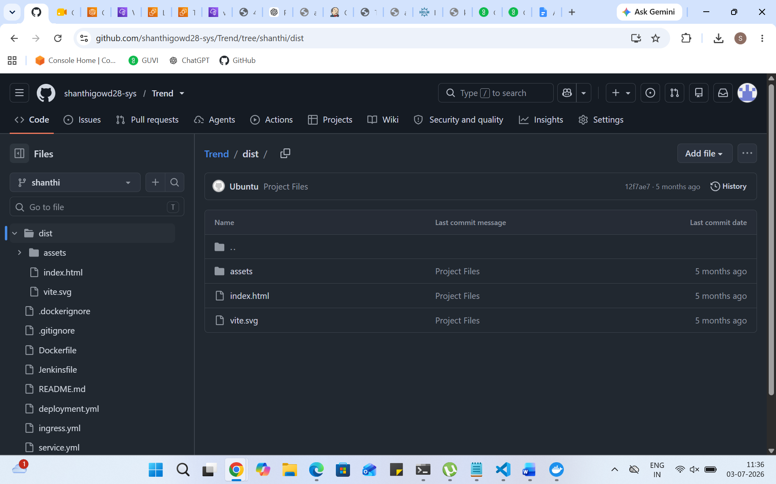
- Add gitignore and dockerignore files and use CLI commands to push code.

- Here is the gitignore and dockerignore files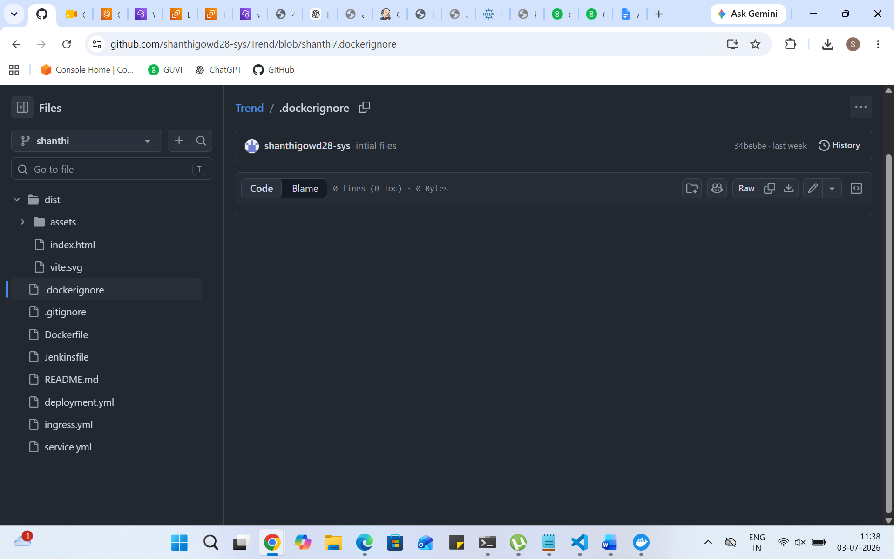
Jenkins:
- Install Jenkins and necessary plugins (Docker, Git, Kubernetes, Pipeline) for build, push &deploy applications.
- 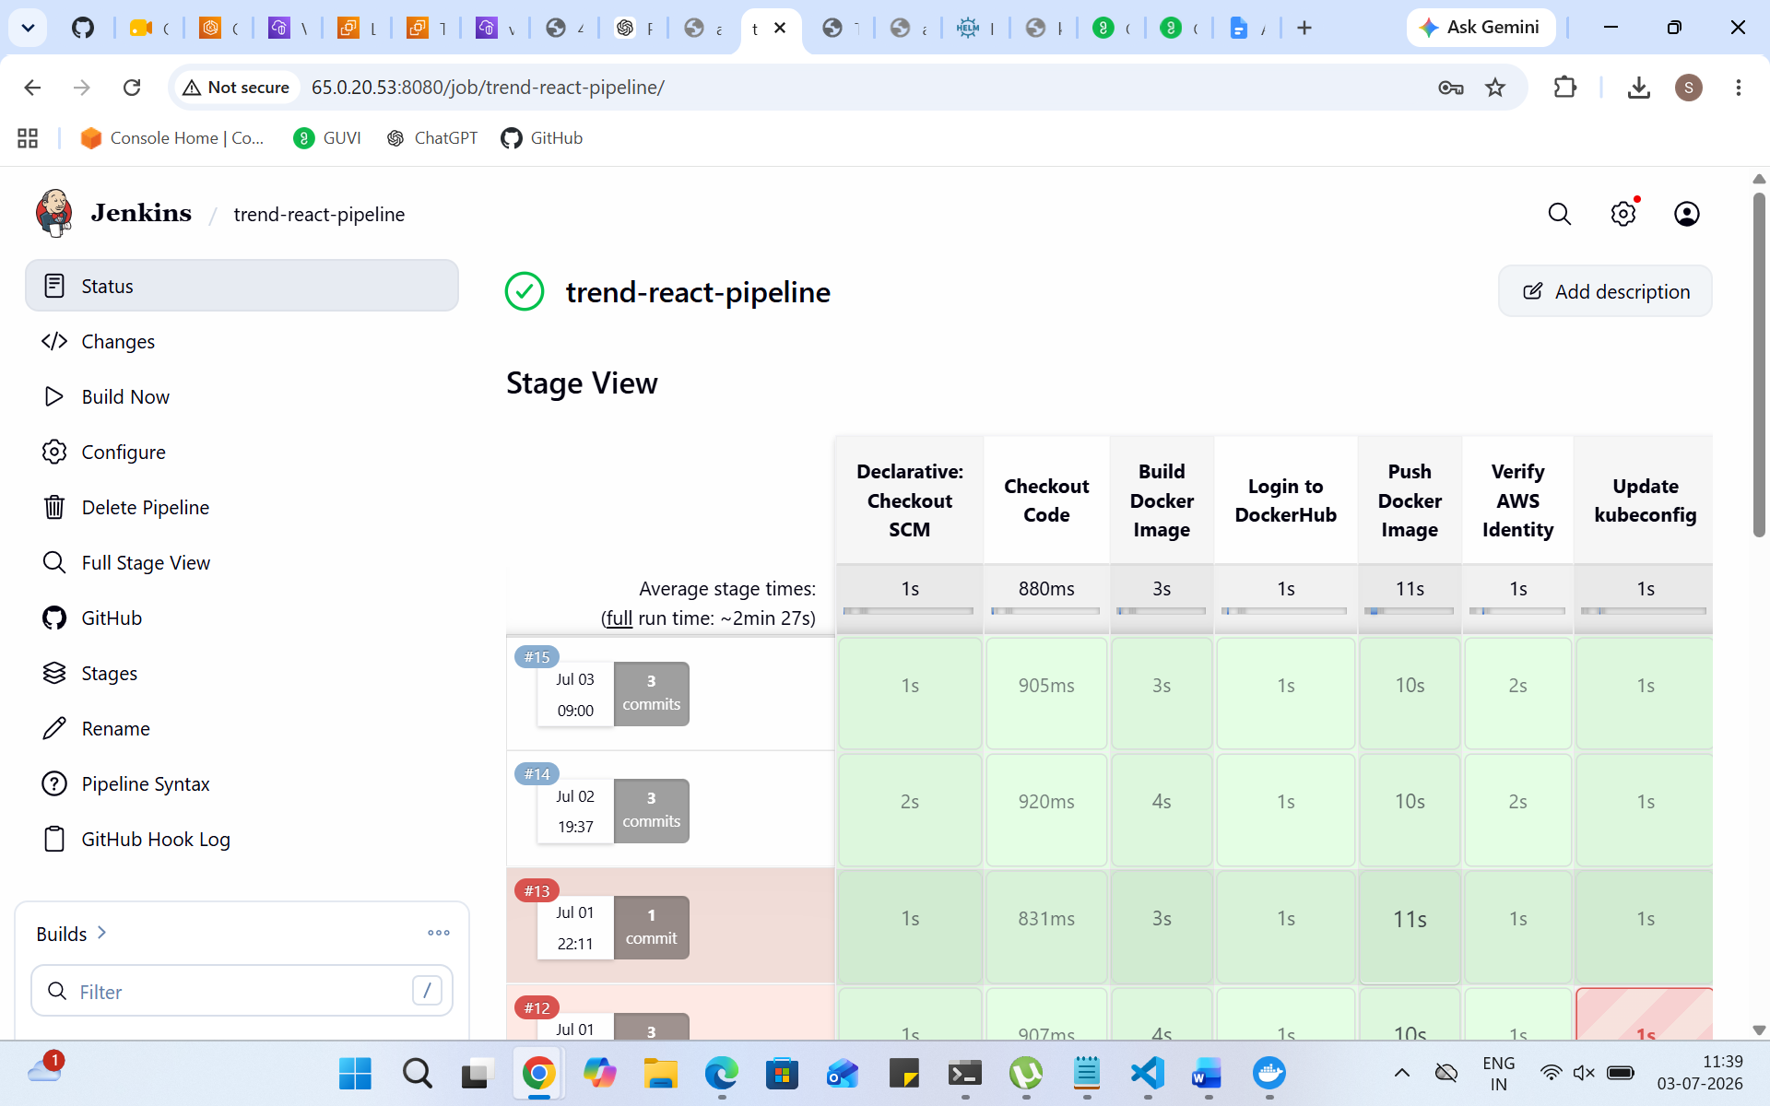
- Setup Github and jenkins integration using github webhook build trigger for auto build for every commit.
- 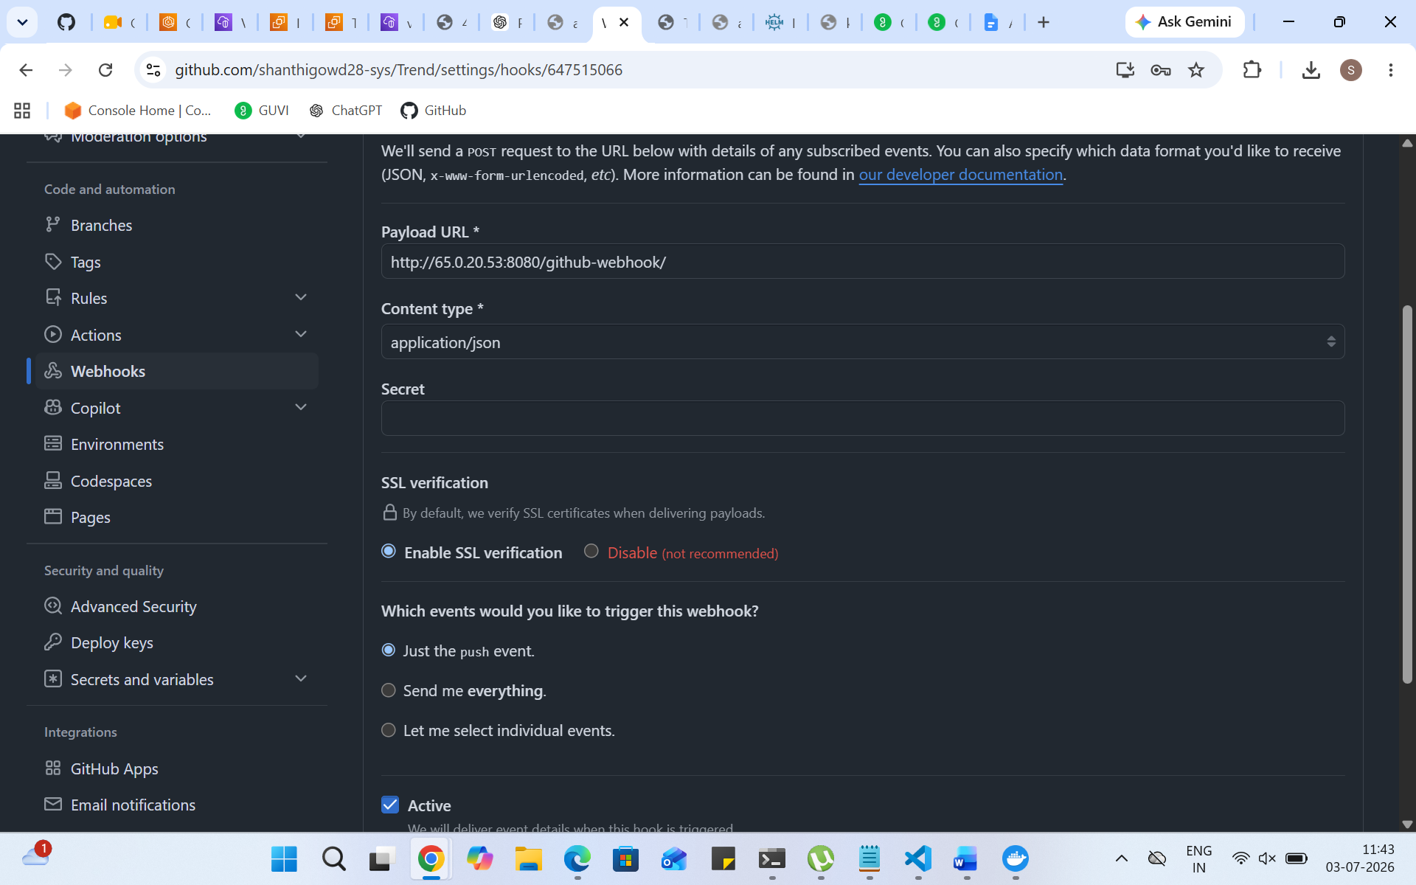
- Create a declarative pipeline script and pipeline project to build, push & deploy using CI-CD.
- 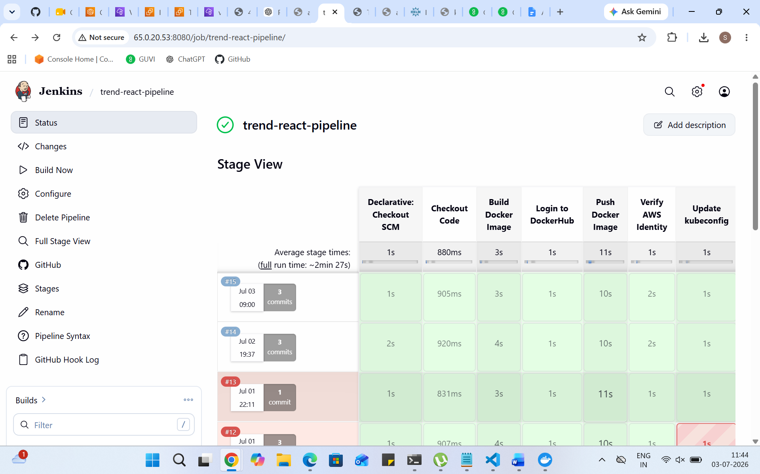here is the pipeline
Monitoring:
- Setup a monitoring system to check the health of the cluster or application (opensource) is highly appreciable.
- 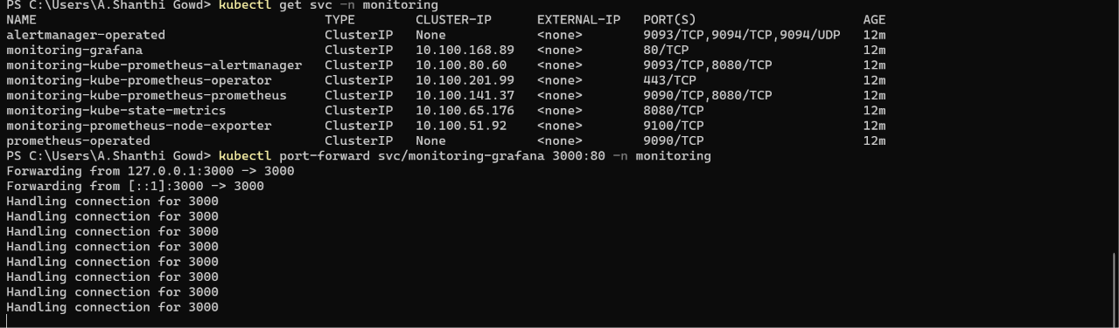

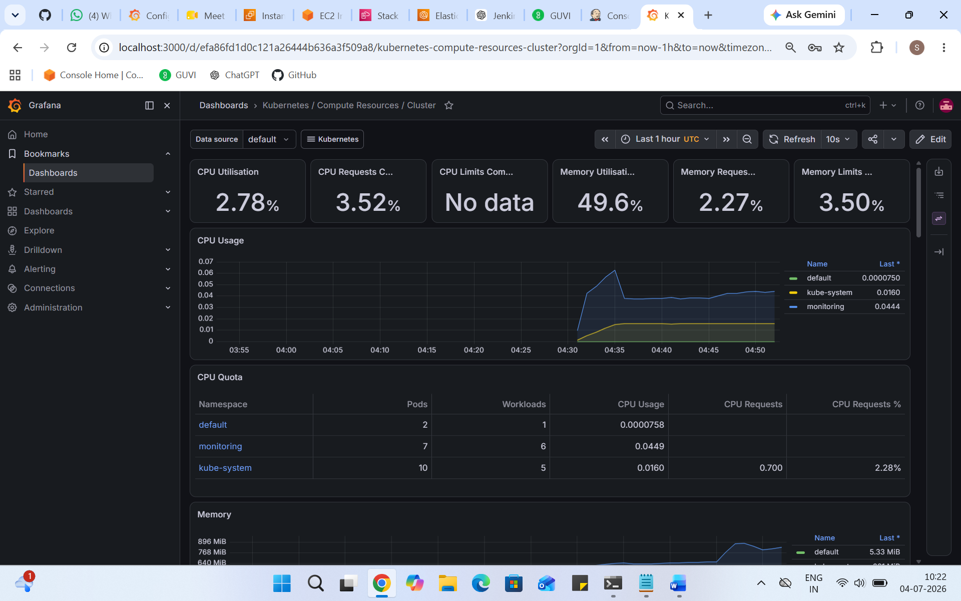
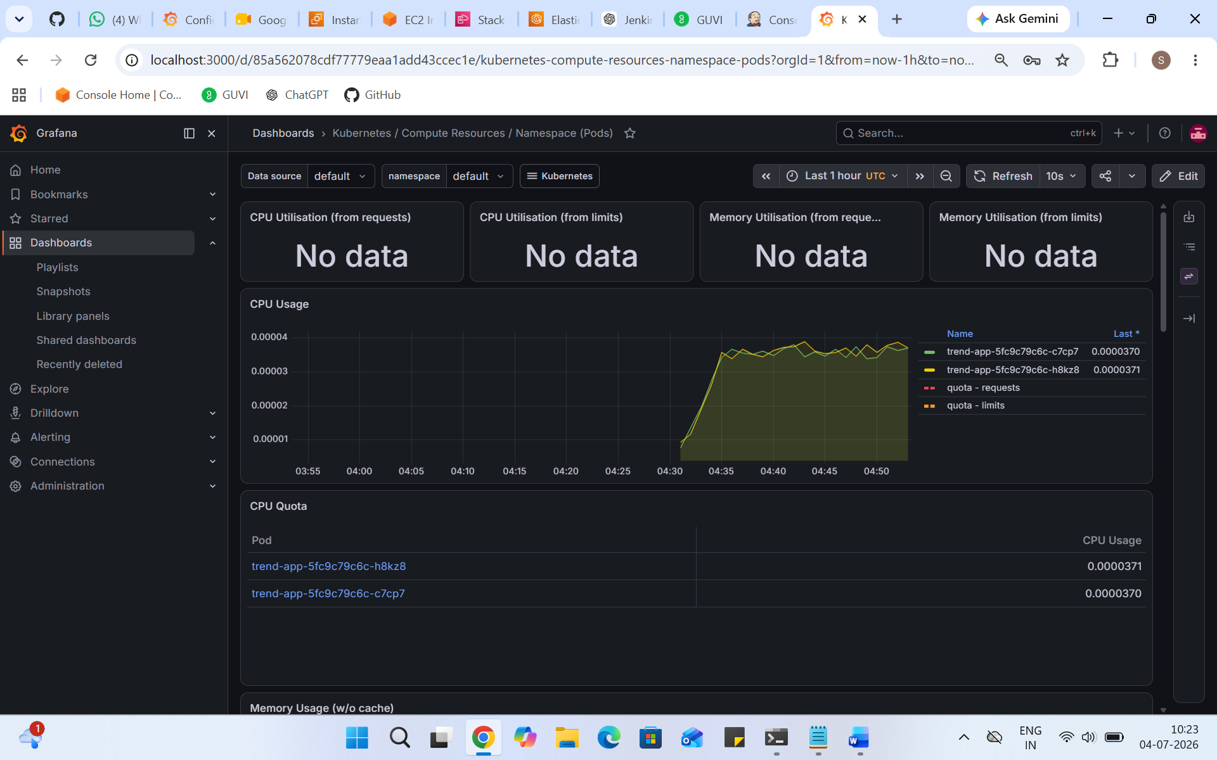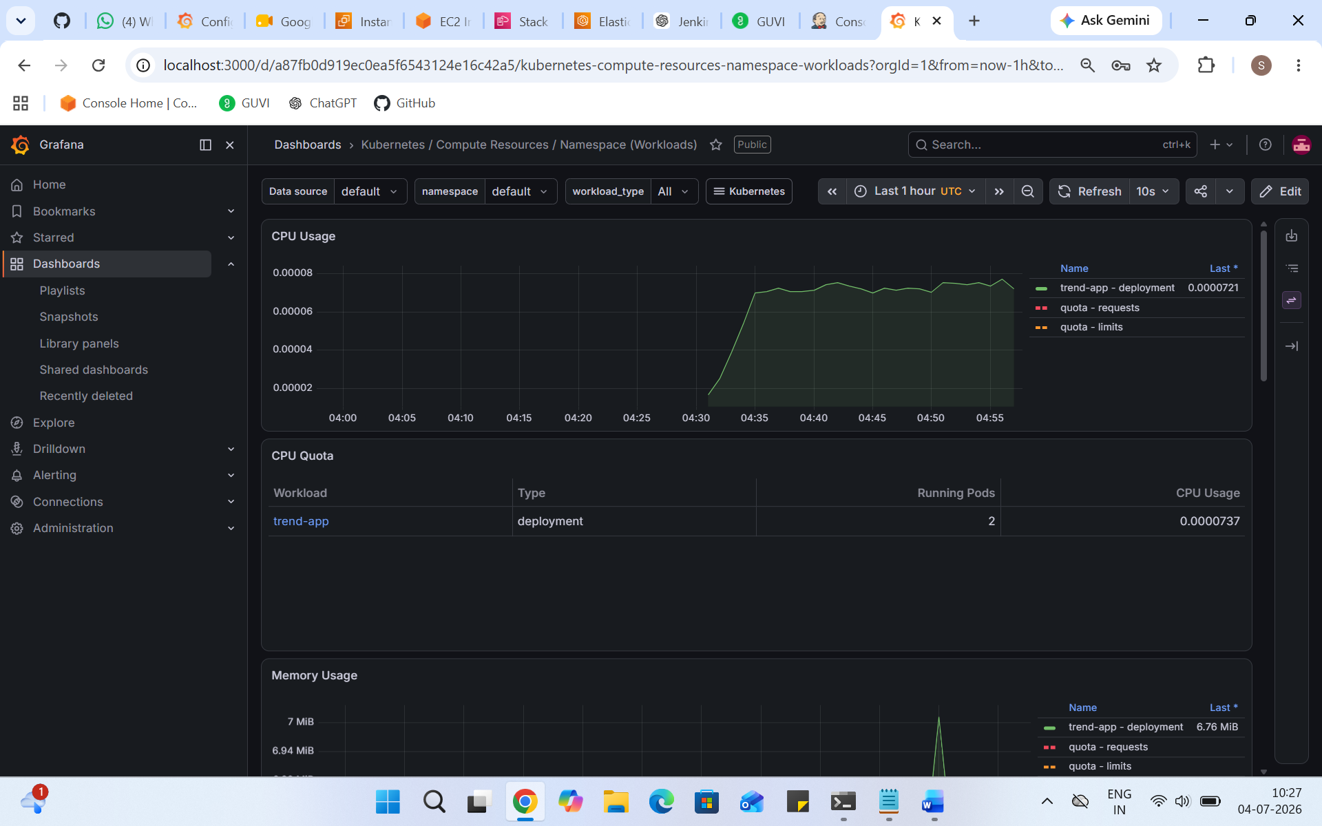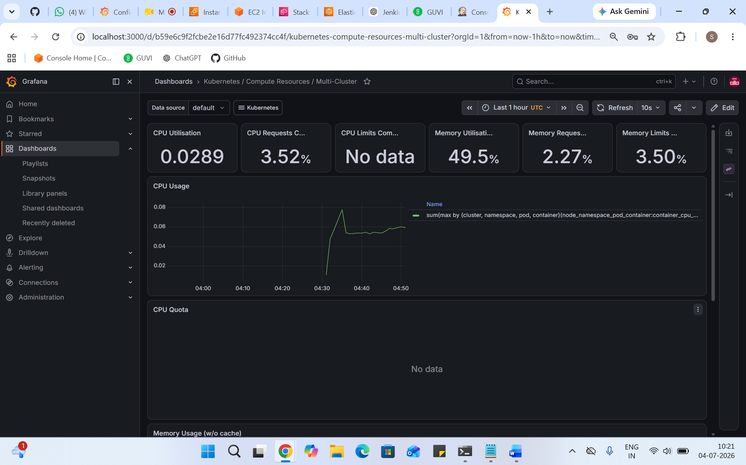
Submission Guidelines:
- GitHub Link: Submit full code repository.
ht
- README File: Include setup instructions, pipeline explanation, and screenshots or create a document and attach all screenshots.
This is the document with all screenshots.
- Application deployed kubernetes Loadbalancer ARN.
arn:aws:elasticloadbalancing:ap-south-1:013416764825:loadbalancer/app/k8s-default-trending-0bf8cf1b09/66545f63cdb30034
this is load balancer arn.

